Summary:

In March-April 2011, in response to thermal management issues on the RBSP-EFW flight model Low-Voltage Power Supply (LVPS) PWAs, RBSP-EFW instrument management and RBSP-Project management decided to design and fabricate and new set of flight LVPS PWAs, the LVPS-2 PWAs. This was done so that if at a later time replacement of the original LVPS PWAs was required due to a failure during Observatory-level integration and test, suitable replacement flight PWAs would be available.

At that time UCB/SSL did not have the technician resources to fabricate the magnetics for the LVPS-2 PWAs, while JHU/APL did. So, parts kits and instructions were put together by the LVPS CogE, Selda Heavner (UCB/SSL) and provided to Kim Cooper and Anthony Stump (JHU/APL) in support of the fabrication effort.

Discussions of the details of the fabrication (assembly drawings and instructions) continued through June and July 2011, with fabrication starting in Aug 2011, and the first batch being completed and shipped back to UCB/SSL for evaluation in early Sep 2011.

All 12 pieces of the first batch were evaluated by the LVPS-2 CogE (Selda Heavner) and UCB/SSL QA for workmanship and electrical properties. Three of the 12 passed workmanship and electrical testing, the remaining nine did not. The details of the electrical and workmanship results are tabulated below. Details of the visual inspections of each piece are included in the subsequent figures.

On the basis of these results, UCB/SSL decided to pursue other options for fabricating the new flight magnetics, and eventually (Nov 2011) found an outside vendor (Pulse Electronics) to provide fabrication services which has to date (Feb 2012) worked out very well.

While there are particular issues with the fabrication of each failed piece in the batch that explain the failure of that piece, with such a high rate of failure, one tries to find a deeper root cause.

One overarching issue with this effort arose in the communication of the fabrication details between the LVPS CogE at UCB/SSL and the fabrication technicians at JHU/APL. The standard fabrication drawings and instructions used at UCB/SSL for magnetics fabrication were quite terse compared to the drawings and instructions used at JHU/APL for the same sort of task, and when the UCB/SSL drawings and instructions were transferred over to JHU/APL, a significant clash of expectations occurred, possibly leading to the issues with the final product.

These relatively terse assembly drawings and instructions suffice at UCB/SSL due to the particularly close and long-standing working relationship between the power supply group at UCB/SSL (Berg, Heavner et al.) and the flight electrical technician in charge of magnetics fabrication at UCB/SSL, Ms. Helen Yuan. However, when it came time to “out source” the work, well-understood details of the fabrication process were lost or misunderstood, leading to the observed failures.

Details:
APL Magnetics Provided for RBSP LVPS II Construction

Part Number | Description | Failure Description | Possible Cause
RBSP 003 | Feedback Filter Inductor | Failed Inductance | Loose winding
RBSP 005 | Inductor P5, P3.6 P1.8V | Failed Inductance | Nothing visible. Unknown. Core problem?
RBSP 008** | Weinberg Inductor | Failed Inductance (too low) | Clamps do not have enough pressure.  Squeezing the clamps increase inductance
RBSP 009 | Feedback Transformer 225V | Failed Resistance | Uneven winding
RBSP 016 | Inductor Differential | Failed Inductance | Crossed wires
RBSP 017 | Inductor Common Mode | Passed | Passed
RBSP 018 | INDUCTOR Housekeeping | Failed Resistance  Inductance Pass but too high | Kinks in the wire and loose winding, cross winding
RBSP 020 | Sync Transformer | Failed Inductance | Contamination and crossed wires
RBSP 021 | TRANSFORMER Sync Dual | Passed | Passed
RBSP 022 | Inductor Common Mode BEB Analog | Passed | Passed
RBSP 024 | Inductor Common Mode | Failed Resistance | Crossed wires
RBSP 025 | Inductor Common Mode | Failed Resistance | Loose winding not perfectly touching the core

** No picture provided for RBSP 008. The clamp did not have enough pressure to keep the cores closed. The picture under microscope did not show any difference.

RBSP 003: Top and bottom pictures show that the winding is very loose. The winding should be tight and touching the core. (The winding separation is very good).

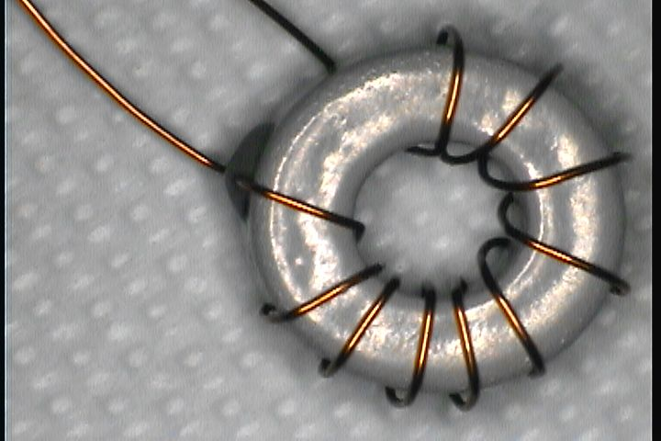

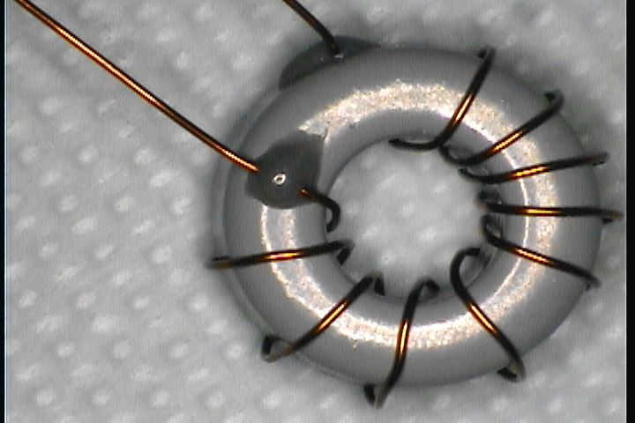

RBSP 005: No visual or obvious reason to fail. Possible cracks on the core. No visible faults under microscope. Applying pressure did not change inductance.

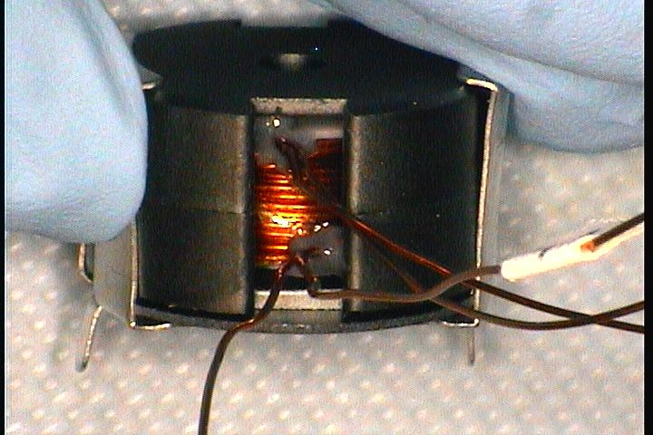

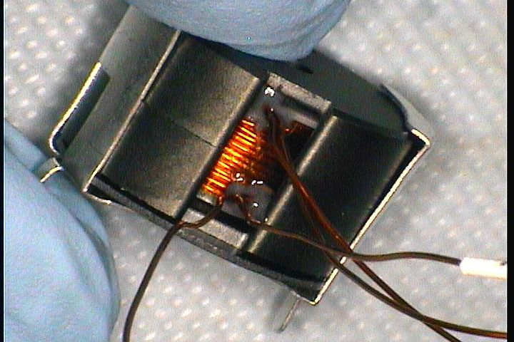

RBSP 009: Top picture shows uneven winding inside the core. To the left of the core winding style has changed. Bottom picture also shows the uneven spacing of the wires.

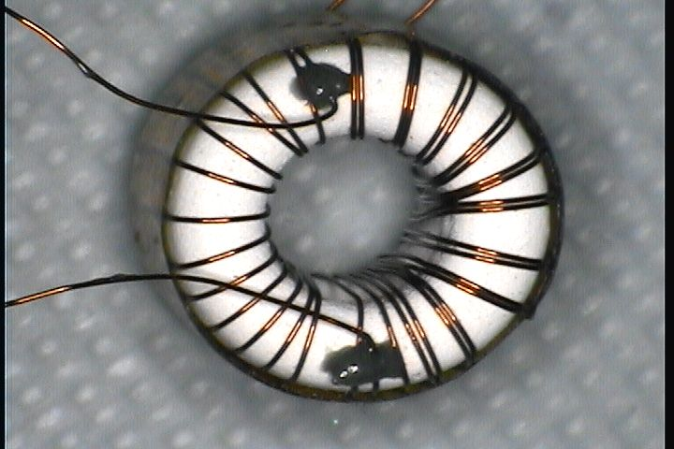

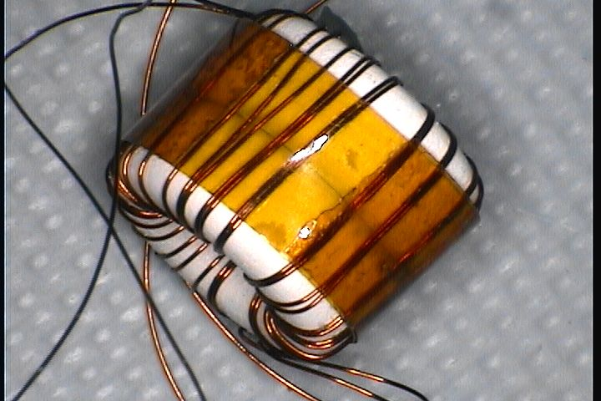

RBSP 016: Crossed wires can be seen on both top and bottom picture (left before exiting bottom picture shows crossing of the wires inside and outside of the core).

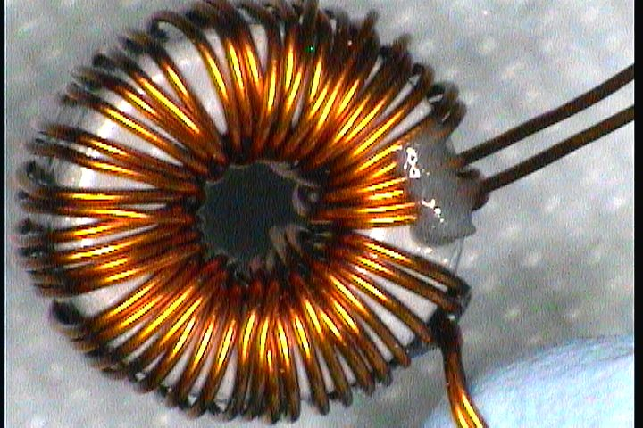

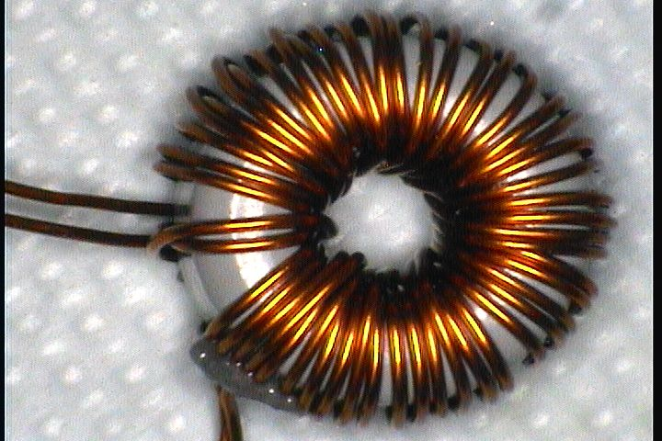

RBSP 017: All tests passed. Very good construction

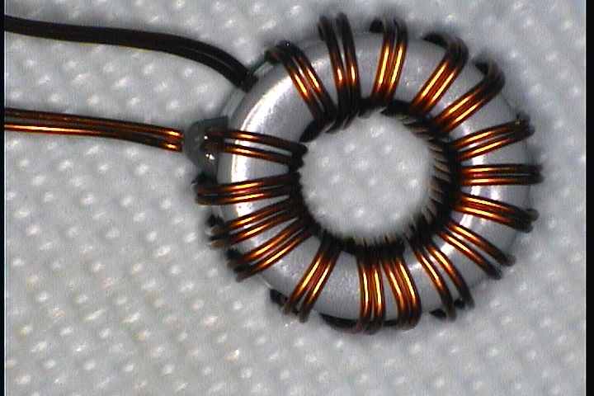

RBSP 018 Picture 1 is below: On the left of the picture the wire seems loose and not perfectly touching the core as it is on the right side. 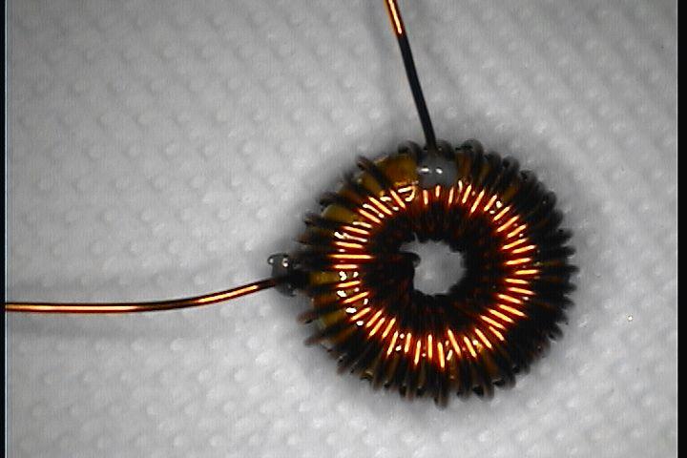

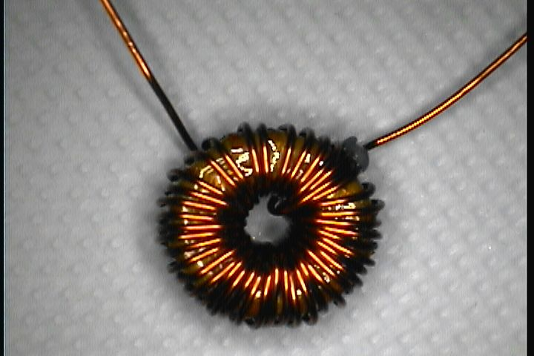
RBSP 020: This pictures shows that there is some kind of a contamination on the wires. They look like white dots and the wire is crossed.

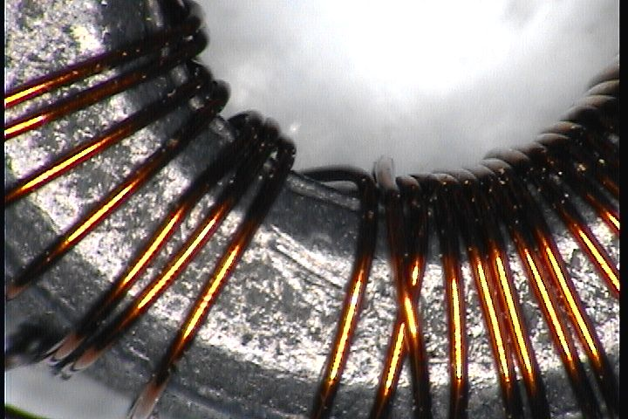

RBSP 021: There is no problem with winding but kapton tape has gaps and not attached perfectly. Could be fixed by re-applying the kapton tape.

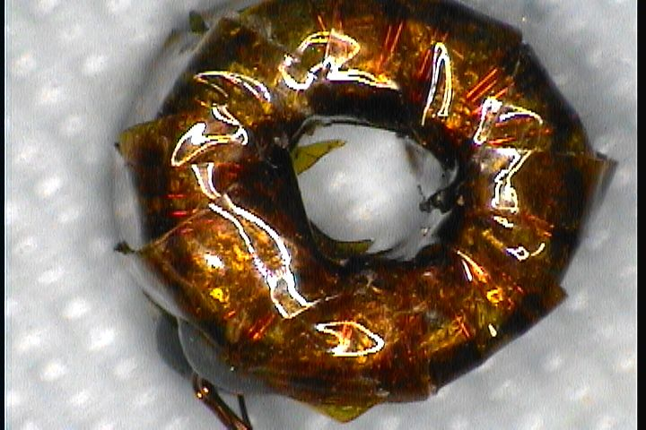

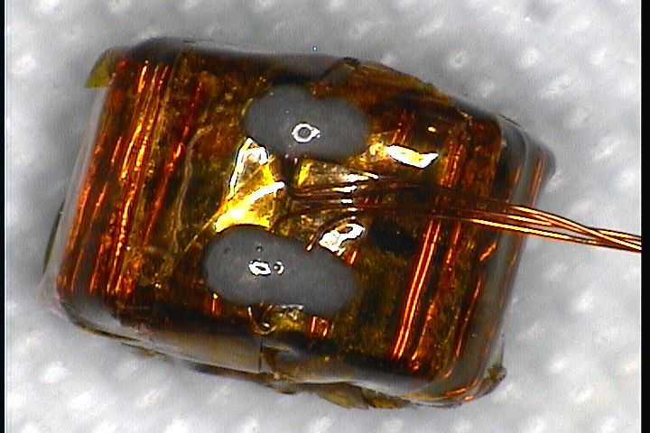

RBSP 022: The tests passed.

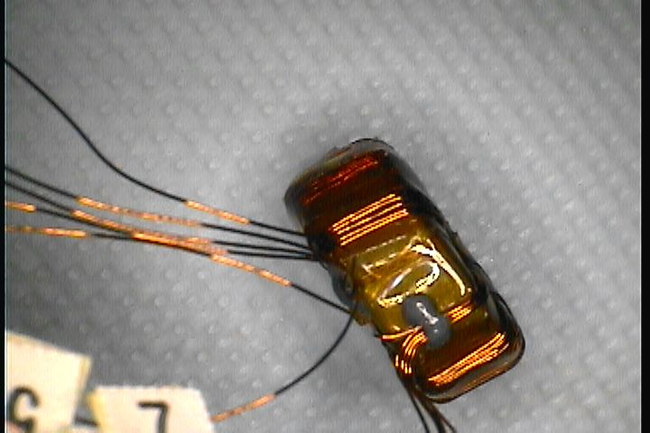

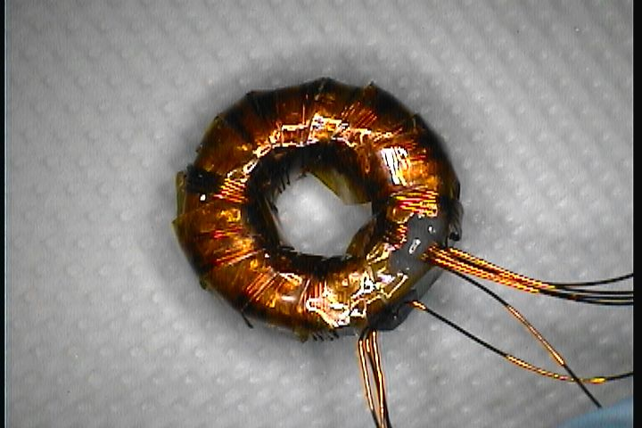

RBSP 024: Kinks in the wire and if you look on the left side of the top picture you can see that wires are crossing each other. The wires should remain parallel.

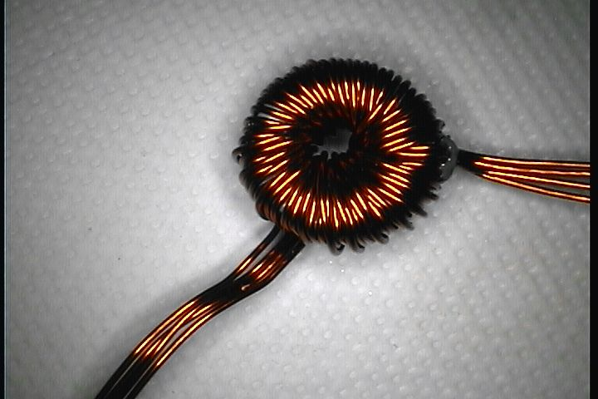

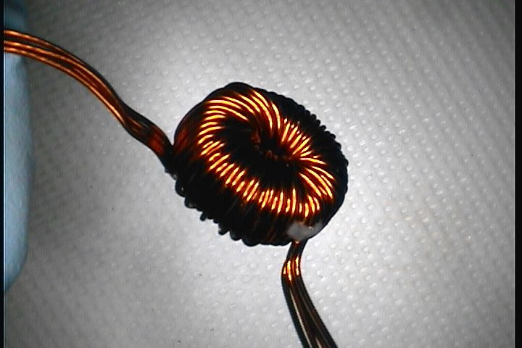

RBSP025:
This inductor failed resistance. There are kinks in the wire and if you look inside the core you can see the wires are not perfectly touching the core and they are not evenly spread out. It passes Inductance
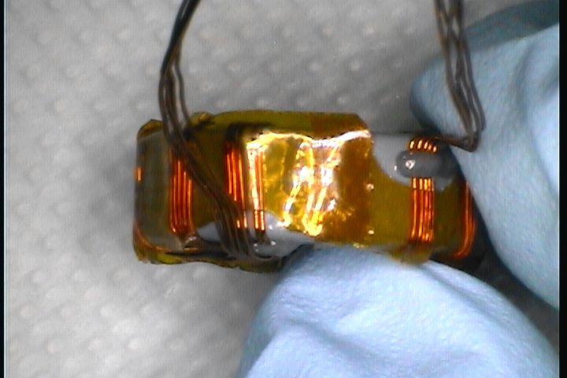
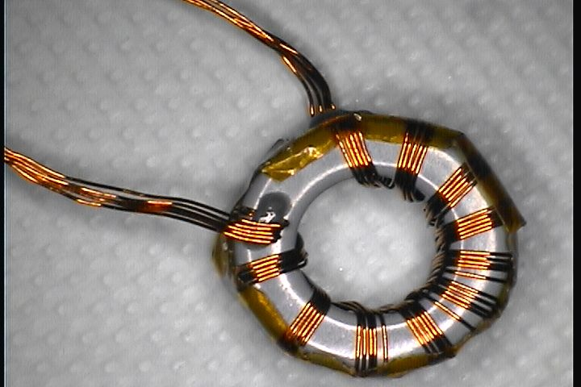

Revision History:
- Rev A, Selda Heavner and John Bonnell, UCB SSL, Jan 2012.
  - Initial revision, incorporating summary test report results and discussion.

